2019 Guidelines on Development Grants Procedures

- Summary of Grant Categories

The overall scheme consists of two schemes rolled in to one. The Central Council Scheme has a budget of €640,000, while the Munster Council Scheme has a budget of €490,000. This gives an overall budget of €1,130,000

The scheme consists of 8 categories, with all apart from Category 5, funding activity at club level. Category 5, which deals with County Ground Development, has its own budget under the Munster Council Budget Framework and is not part of the €1,030,000 outlined above.

Central Council funds categories 1, 2, 6a, 6b, 6c, 6d, 6e and 8, while the Munster Council funds all 8 categories. Please note that the one application form will suffice for both schemes.

Each category has an expenditure ceiling, which means that expenditure beyond this amount is not funded. Therefore, if the ceiling of a particular category is €100,000 and a club spends €250,000, it is effectively the first €100,000 of expenditure that is eligible for funding.

Categories 1,2,3,4, 7 and 8 are considered as ‘statutory’ and therefore, these categories are dealt with first, meaning the full amount due under the scheme is paid. For example, if a club spends over €175,000 on land purchase (see Category 1), the club will receive the full €20,000 committed under the scheme.

The amount of funding available for category 6 depends largely on the number of applications received and the amount left over after categories 1,2, 3, 4, 7 and 8 have been satisfied. Therefore, it is unlikely that there will be sufficient funding to satisfy the max grants available as outlined below. An estimate to use is that around 10% to 15% of the ceiling expenditure will be available. This is not a commitment, but an estimate.

The 8 categories are now outlined in greater detail. Please take note of the expenditure ceiling in each category.

- Category 1 Grants (Purchase):

  - The level of purchase grant shall be 20% of eligible expenditure to a maximum grant of €20,000. The expenditure ceiling is €150,000. The first €25,000 of a purchase will not be considered for funding, which effectively places the expenditure ceiling on the amount eligible for grant aid at €125,000.

  - A purchase is considered as one purchase, no matter how many folio numbers are involved. A club that receives a purchase grant to the maximum of €20,000 will not be entitled to a purchase grant for another 5 years.

  - This section of the scheme is funded equally by Central Council and the Munster Council.

  - Grants shall not be paid except where:

    - It is established that the ground the subject of the application is vested in the Association and the property is held in trust under a current and adequate Deed of Trust
    - The Registered File Plan Folio of the property is provided, or the ‘dealing number’ in the case of property that is in the process of being registered with the Land Registry or equivalent documentation or certification in the case of unregistered land.
    - The amount of the purchase price of the ground is certified by way of Contract or Deed of Transfer or certification by the Solicitor or Estate Agent dealing with the sale
    - Permission for purchase has been granted by Co Board, Munster Council and National Finance and Management Committee.
    - It is established that land being purchased is for the purpose of pitch development, clubhouse development, or hurling wall development. In other words, land being used for the playing and development of the games will be funded.

- Category 2 Grants (Changing Room Complex):

  - The level of purchase grant shall be 20% of eligible expenditure to a maximum grant of €20,000. That results in an expenditure ceiling of €100,000.

  - This section of the scheme is funded equally by Central Council and the Munster Council.

  - Applications under this category are confined to the construction of new buildings. However extensions to existing building will be considered.

  - Applications in relation to the reconstruction or refurbishment of existing changing rooms, where the total overall expenditure is less than €40,000, shall be considered under Category 6 – Other Club Development Projects.

  - Clubs cannot apply under this category at the same site for a five year period after having received such a grant.

  - Grants shall not be paid except where:
    - It is established that the premises the subject of the application is vested in the Association and the property is held in trust under a current adequate Deed of Trust
    - The Registered File Plan Folio (See Appendix 1 for further explanation) of the property is provided, or the ‘dealing number’ in the case of property that is in the process of being registered with the Land Registry or equivalent documentation or certification in the case of unregistered land.
    - The total claimed expenditure is fully vouched as required at 11(e) below
    - The dressing rooms are completed and are available for use at time of application.
    - This grant is intended for the development of facilities directly associated with the playing of the games i.e. dressing rooms, shower facilities and referee changing rooms.

- Category 3 Grants (Schools Grounds Purchase & Development):

  - The level of school grounds purchase and development grant shall be 15% of eligible costs to a maximum of €5,000.

  - This section of the scheme is funded solely by the Munster Council.

- Category 4 Grants (Construction or Refurbishment of Handball Court):

  - The level of grant for New Courts shall be 15% of eligible costs to a maximum of €5,000

  - The level of grant for Refurbishment of existing Courts shall be 20% of costs to a maximum of €2,500

  - This section of the scheme is funded solely by the Munster Council.

- Category 5 Grants (County & Major Grounds):

  - The budget for the County Development Grants is managed through the provisions of the “2015 to 2024 Budget Framework” as approved by the Munster Council. This section of the scheme is funded solely by the Munster Council.

- Category 6 Grants (Other Club Development Projects):

  - The level of grant awarded under this category will be dictated by the number of applications received and the amount available in the fund after the Grant Categories 1 to 4 and 7 and 8 have been dealt with. The amounts and percentages, as stated below, are only maximum limits applied and not guaranteed levels of the grant to be awarded.

  - Please note that this section of the scheme is funded equally by Central Council and the Munster Council.

  - Eligible expenditure under this category shall be confined to the following categories

Category 6a: Floodlighting of playing pitches, astroturf playing facilities, hurling walls and training areas. Floodlights must be of a minimum 250 lux and a minimum expenditure of €10,000 is required in order to qualify. Certification from the electrical contractor is also required in order to show that lighting meets all require safety and other standards.

Category 6b: Development of a new pitch, including the development of astroturf playing facilities and training areas. Sanding as part of general maintenance is excluded. A minimum expenditure of €10,000 is required in order for pitch works to be considered as development. Expenditure in this category cannot be rolled up over a number of years.

Category 6c: Hurling Walls, including the astro turf area associated with the wall that is not part of a greater training area.

Category 6d: Development of ancillary facilities e.g. goalposts, dugouts, fencing, nets, scoreboard, gymnasiums etc. In order for a club to qualify for a gymnasium grant, proof of competence to operate a gym in a safe manner must be provided.

Category 6e: Development of works which are not playing pitch related e.g. car-parks, stand, medical rooms, grass cutting equipment etc. It also includes upgrade work to dressing rooms that is not included under category 2. Note: Walkways, saunas etc. are excluded.

  - Subject to the level of funding available in any year (see 12 below) the level of grant available in each of the above categories shall be as follows;

Category 6a: 20% to a max grant of €20,000 – expenditure ceiling of €100,000
Category 6b: 20% to a max grant of €20,000 – expenditure ceiling of €100,000
Category 6c: 20% to a max grant of €10,000 – expenditure ceiling of €75,000
Category 6d: 20% to a max grant of €10,000 – expenditure ceiling of €50,000

Category 6e: 20% to a max grant of €10,000 – expenditure ceiling of €50,000

  - To qualify for grant aid under any category 6 category, a minimum expenditure of €5,000 is required. Smaller units will be permitted to satisfy this requirement by combining expenditure over a maximum of two years. Grant aid is project specific so new projects in the category will be considered. For example, if a club receives a grant for developing a new pitch and decides to develop a second pitch two or three years later, they will be entitled to a grant as it is a new project.

- Category 7 Grants (Sanding Grant Scheme):

  - The level of sanding scheme grants shall be 50% of sanding cost to a maximum of €2,000 p.a. for a maximum of three years

  - Applications under this category shall be processed via the Coaching & Games Development Sub-Committee using the approved criteria for the scheme, this will include detailed invoices outlining sand transport and purchase costs.

  - This category of Sanding Grant is only available to a limited number of Clubs per County i.e. 2, over a 3 year cycle.

  - Grants will only be approved to clubs who make their pitches generally available for schools and colleges fixtures.

- Category 8 Grants (Property Ownership Regularisation Grant):

- This grant is made available to clubs who undertake to regularise the legal ownership of their property in accordance with GAA Rules on assets and Trustees.

- This grant assists clubs with the legal fees associated with the regularisation of the title ownership of their property, along with the vesting of such property in the GAA.

- The maximum grant available for this is €700 per club.

- This section of the scheme is funded equally by Central Council and the Munster Council.

- The following table summarises each of the categories, along with the maximum grant available and the expenditure ceilings.

 |  |  |  | Munster Council |  | Central Council |  | Max Grant Available
Category 1 - Purchase
 | Grant level - Percentage |  |  | 10% |  | 10%
 | Maximum Grant Available |  |  | €10,000 |  | €10,000 |  | €20,000
 | Grant Expenditure Ceiling |  |  | €100,000 |  | €100,000
Category 2 – Changing Rooms
 | Grant level - Percentage |  |  | 10% |  | 10%
 | Maximum Grant Available |  |  | €10,000 |  | €10,000 |  | €20,000
 | Grant Expenditure Ceiling |  |  | €100,000 |  | €100,000
Caetgory 3 - Schools Grounds Purchase and Development
 | Grant level - Percentage |  |  | 15% |  | 0%
 | Maximum Grant Available |  |  | €5,000 |  |  |  | €5,000
 | Grant Expenditure Ceiling |  |  | €33,000
Category 4 - Construction and Refurbishment of Handball Alley
A | Grant level - Percentage |  |  | 15% |  | 0%
 | Maximum Grant Available |  |  | €5,000 |  |  |  | €5,000
 | Grant Expenditure Ceiling |  |  | €33,000
B | Grant level - Percentage |  |  | 20% |  | 0%
 | Maximum Grant Available |  |  | €2,500 |  |  |  | €2,500
 | Grant Expenditure Ceiling |  |  | €12,500
Category 6 - Other Club Development Projects
6A | Grant level - Percentage |  |  | 10% |  | 10%
 | Maximum Grant Available |  |  | €10,000 |  | €10,000 |  | €20,000
 | Grant Expenditure Ceiling |  |  | €100,000 |  | €100,000
6B | Grant level - Percentage |  |  | 10% |  | 10%
 | Maximum Grant Available |  |  | €10,000 |  | €10,000 |  | €20,000
 | Grant Expenditure Ceiling |  |  | €100,000 |  | €100,000
6C | Grant level - Percentage |  |  | 10% |  | 10%
 | Maximum Grant Available |  |  | €7,500 |  | €7,500 |  | €15,000
 | Grant Expenditure Ceiling |  |  | €75,000 |  | €75,000
6D | Grant level - Percentage |  |  | 10% |  | 10%
 | Maximum Grant Available |  |  | €5,000 |  | €5,000 |  | €10,000
 | Grant Expenditure Ceiling |  |  | €50,000 |  | €50,000
6E | Grant level - Percentage |  |  | 10% |  | 10%
 | Maximum Grant Available |  |  | €5,000 |  | €5,000 |  | €10,000
 | Grant Expenditure Ceiling |  |  | €50,000 |  | €50,000

- General Procedures & Processing of Applications:

  - Grants shall be categorised as follows:
        - Category 1 - Purchase of ground for playing pitch (including
first, second or third pitch)
    - Category 2 - Construction of new Dressing Rooms or
Extension of existing Dressing Rooms
    - Category 3 - Schools Grounds Purchase & Development
    - Category 4 - Construction or Refurbishment of Handball Court
    - Category 5 - County & Major Grounds Development
    - Category 6 - Other Club Development Project
    - Category 7 - Sanding Grant Scheme
    - Category 8 - Regularisation of legal ownership of property

  - Application forms and guidelines for the various grant categories shall generally be issued not later than the end of May each year.

  - The closing date for grant applications shall be the last Friday, in September each year.

  - Applications for grants received in Comhairle na Mumhan after the last Friday, in September in any year and incomplete applications received before that date shall be returned to the County Board or Club in question. Late applications shall be re-submitted for processing and approval the following year.

  - Applications shall be deemed incomplete if any of the following is not supplied:
    - Fully completed application form giving all particulars required in relation to Vesting of Ground and Deed of Trust.
    - File Plan Folio for the property
    - Supporting documentation of a financial nature: including invoices (not statements or copy cheques) detailing the nature and vouching all expenditure amounts claimed.
    - Documentation showing proof of payment, namely a Bank Statement showing the payment of the amount detailed on the invoice
    - Invoices must breakdown all costs, invoices outlining a total expenditure figure are not acceptable. Invoices marked paid MUST have suppliers stamp
    - For Category 1 applications Copy of letters from Co Board, Munster Council and NFMC authorising purchase of grounds.
    - Bank statements to support any claimed overdraft situation deemed relevant to the application.
    - Completed Health and Safety statement for club grounds and facilities.
    - Club Child Safeguarding Statement (new requirement in 2018)
    - Any other documentation deemed necessary to support an application under any category from time to time
    - Certification and recommendation of the relevant County Board Officer and the Board representative on the Planning & Development Committee of the Provincial Council

  - Only expenditure of a capital nature (providing a long term asset) is eligible for support under the Grant Schemes. Expenditure on ongoing maintenance and repairs is excluded as follows:

    - Grass Cutting
    - Servicing of maintenance equipment including mowers and tractors
    - Fertiliser and weed killer purchases
    - Maintenance or painting of existing premises, glass breakages, plumbing or electrical repairs etc.
    - Lease or rent of temporary facilities
    - Consultancy fees on preparation of Lottery submissions
    - Purchase of equipment including Tractors etc. Grass mowers are included under category 6.

  - Applications for grants shall only be considered from County Boards, affiliated clubs, handball clubs and schools, except in exceptional circumstances, within the province of Munster.

  - In general only one application can be made for grant approval for the same project and proposed phasing of development must be stated in all applications for grants in first year of application. This must include detailed analysis of project including timescale, plans, breakdown of costs per stage and any other documentation deemed necessary. Failure to provide documentation will render project ineligible for consideration as a phased development.

  - All GAA units in receipt of development grant funding are required to provide the use of their facilities to provincial, county, clubs, schools, colleges and other GAA units free of charge.

  - Clubs found to be submitting incorrect or fraudulent documentation will be subject to sanctions as deemed appropriate by the Council up to and including suspension from the scheme and repayment of monies paid.

  - All applications shall be submitted to the Munster GAA HQ at “Áras Mumhan”, Caislean Nua, Caladh an Treoigh, Luimneach. Decisions on all eligible grant applications shall be made before the second Friday of the month of December each year subject to completion of spot checks by Munster Council officials.

  - All grant payments shall be made in favour of the applicant unit and will be paid out at a meeting organised in each County by the Munster Council representative. Payments in respect of approved grants shall be paid, where possible before the end of the year.

- Development Grants Budget:

  - The budget for club development grants (Cats 1, 2,3,4,6, 7 and 8) shall be based on a three year cycle. The combined Central Council and Munster Council budget for the period 2013-2015 shall be €1,030,000 per annum. This amount will be ring fenced solely for club developments and includes Central Council funding. The budget will be reviewed at the end of each three year term.

  - The budget for County development grants (Cat 5) is catered for under the ‘Budget Framework Agreement’.

  - Where significant additional funding becomes available to the Council e.g. replay gate receipts, additional resources may be used to increase the development grant budget for Category 5 and 6 grants in the current period.

  - Budgets for individual categories of grant shall be provided in the following sequence:

    - Statutory Categories (Categories 1, 2, 3, 4, 7 and 8) shall be provided for and met from the budget in the first instance

    - The balance remaining from the club budget after statutory commitments are met shall be used to fund Category 6 grant commitments. This will be divided on the basis of proportionate expenditure by all the applicant clubs from across the Province in Category 6.

Appendix 1: File Plan Folio

The following text is taken directly from the website of the Property Registration Authority (www.prai.ie) and outlines that a folio is and what is, how to obtain it and looks like

The Register:

The Irish Land Register is one of the most advanced land registers in Europe. The Register is fully computerised and all registered land parcels are digitised. The Register consists of textual and spatial information (folios and maps). The registered land in each county is divided into folios, one for each individual ownership or title. Each folio is numbered sequentially within the county division.

Folios:

The Register is conclusive evidence of title to property and any right, privilege, appurtenance or burden appearing thereon. The title shown on the folio is guaranteed by the State which is bound to indemnify any person who suffers loss through a mistake made by the Land Registry.

Certified Copy Folio/Title Plan:

The folios and maps of the Register constitute a public record and any person may apply to inspect or obtain a copy folio/title plan, on payment of the appropriate fee.

If you know the relevant folio number you can apply for a copy on landdirect.ie or by downloading and completing the Application Form for Copy Folio (fee €40) or Application Form for Copy Folio/Title Plan showing appurtenant rights of way and/or other “special features”, if any, relating to the lands (fee €40) and sending the completed form together with a cheque/postal order for the appropriate fee to:
Customer Service Unit
Property Registration Authority
Chancery Street
Dublin 7

Sample File Plan Folio:

A sample File Plan Folio is included below. This is the document that is required in order to fulfil the development grant criteria.

Part 1 (a) – This will outline the size and location of the land
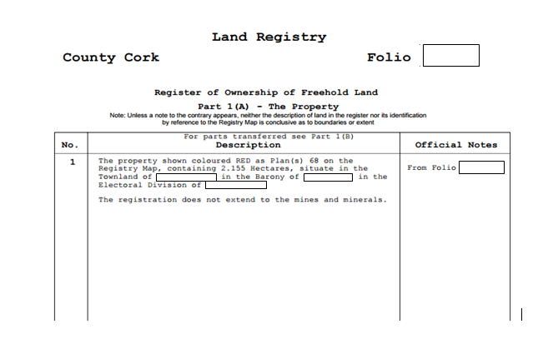
Part 1 (a) – This will outline any parts that have been sold and will also outline and charges or inhibitions that exist on the title
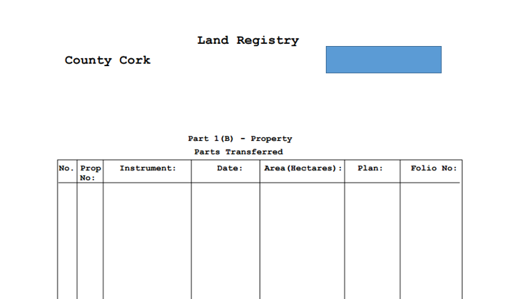

Part 2: Ownership – This part will outline who the owners of the property are.

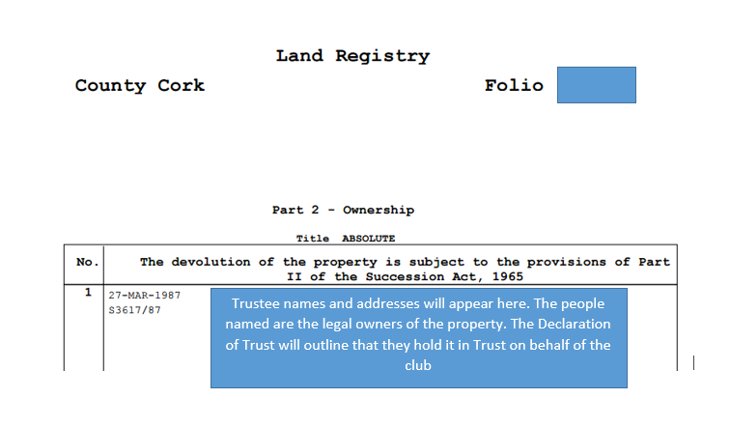

Clubs should contact their solicitor in the first instance as he/she will often have a copy on file. In cases where the registration of the property has been lodged and is awaiting completion, a ‘dealing number’ will be provided. The ‘dealing number’ will be accepted in the place of the File Plan Folio.

